# 1. Using Pivot Tables

## In this lesson, you will learn...

1. To use pivot tables to analyze data.
2. To edit pivot tables.
3. To format pivot tables.
4. To insert pivot charts.
5. To use Slicers.

## Pivot Tables

A pivot table is an interactive table that can be used to analyze, organize, and summarize large amounts of data. Pivot tables make it easy to rearrange data, quickly displaying it in different ways. Pivot tables usually have four types of fields:

1. Page field ( Report Filter ). Use the Page field to filter data by a specific field.
2. Column field ( Column Labels ). Use the Column field to display a field from the source data as column headings.
3. Row field ( Row Labels ). Use the Row field to display a field from the source data as row headings.
4. Data field ( Values ). The Data field is the field from the source data that you want to summarize or analyze.

In the following image, the pivot table shows the average price of homes in different towns based on the number of bedrooms. At the top is a Page field which can be used to show only houses with a specific number of bathrooms:

## Creating Pivot Tables

### Preparing Your Data

Before inserting a pivot table, make sure the data you want to analyze is in an organized table. Things to consider include:

1. Header row. Make sure your data includes a header row because the top row of your table will serve as the field names in your pivot table.
2. No empty rows or columns. If your data includes empty rows or columns, Excel will not treat all your data as one table.
3. No subtotals. Remove all subtotals before creating your pivot table.

### Inserting a Pivot Table

To insert a pivot table in Microsoft Excel:

1. Select any cell in the set of data you want to analyze.
2. On the Insert tab, in the Tables group, click the PivotTable command (and in Excel 2007 and 2010, then select PivotTable ):  
   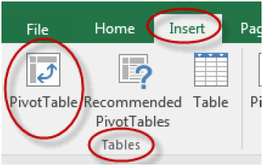
3. In the Create PivotTable dialog box, verify that Excel has selected the correct range, select where you want the pivot table to show up (you will almost always want to select New Worksheet ), and click OK :

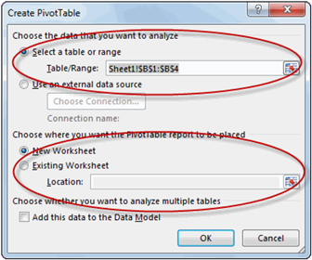

1. In the PivotTable Field List , which opens up on the right (left in Excel 2007/2010) of the worksheet in which your pivot table will be located, drag and drop fields from your data into the Report Filter (Page fields go here),

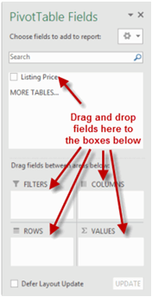

Column Labels (Column fields go here), Row Labels (Row fields go here), and Values (Data fields go here) boxes:

* 1. In the image below, fields have been dragged into the boxes as the first step in creating the report shown at the beginning of this lesson:

1. Excel assumes you want to sum the values of the Data field (the field in the Values box). To perform a different calculation such as Count or Average:  
   Click the field name and select Value Field Settings :  
   Select the calculation you want to perform and click OK :
2. To change the format of the numbers in the pivot table:
   1. Click the field name and select Value Field Settings :  
      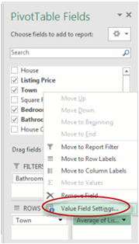
   2. Click Number Format :  
      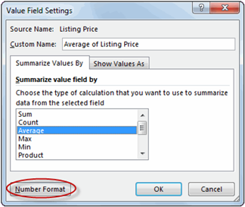
   3. In the Format Cells dialog box, select the number format category, the number of decimal places to show and whether or not to display a comma (if applicable), and then click OK :  
      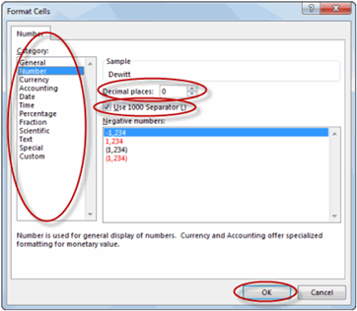
   4. In the Value Field Settings dialog box, click OK :  
      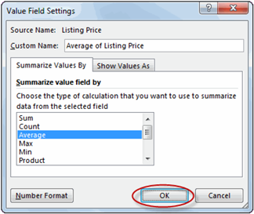

## Inserting Slicers

Slicers make it really easy to filter data in a pivot table. Adding a Slicer is similar to adding a second Page field ( Report Filter ), but it's even easier to use.

To add a Slicer to a pivot table:

1. Select any cell in the pivot table.
2. On the PivotTable Tools Analyze tab ( PivotTable Tools Options tab in Excel 2007/2010), in the Filter group ( Sort & Filter group in Excel 2007/2010), click the Insert Slicer command (and then select Insert Slicer in Excel 2007/2010):  
   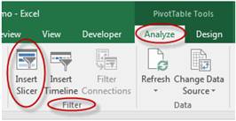
3. In the Insert Slicers dialog box, check the field or fields (Yes, you can create multiple slicers at once!) to use to "slice" your data and click OK :  
   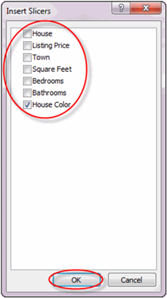
4. To use the Slicer, simply select one of the fields in the Slicer to filter your data by that field:  
   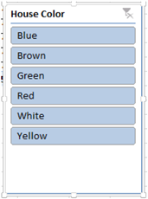

## Working with Pivot Tables

### Grouping Data

You can group data in a Pivot Table to show a subset of your data

To group data:

1. In the Pivot Table, select the data you want to group.
2. Right-click and select Group .  
   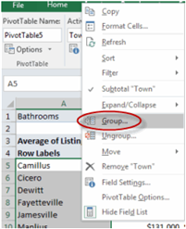
3. The data appears as a new group.  
   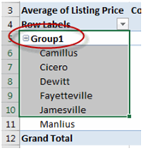

## Using PowerPivot

PowerPivot is an add-on that you can use in Excel 2013 to perform more powerful data analysis.

To add PowerPivot:

1. Select the File menu tab, and then select Options .
2. In the Excel Options dialog box, on the right, select Add-Ins .  
   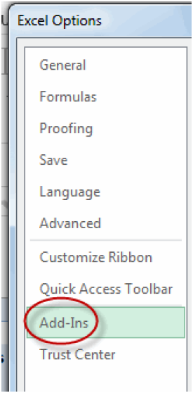
3. From the Manage drop-down list, select COM Add-ins and then click Go .  
   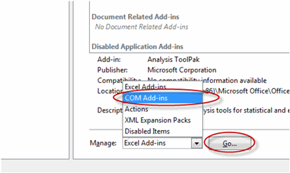
4. Check the Microsoft Office PowerPivot for Excel 2013 check box and click OK .  
   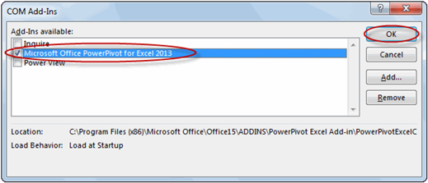
5. The PowerPivot tab now appears on the Ribbon.

Once PowerPivot is installed, you can launch the PowerPivot window by selecting Manage from the PowerPivot tab. Here you can import and manage external data.

## Managing Relationships

A feature that was new with Excel 2013 is the Relationships option on the Data tab, in the Data Tools group.

To manage relationships in Pivot Tables, you must have at least two tables in your worksheet. Then, to create a relationship:

1. From the Data tab, select Relationships .  
   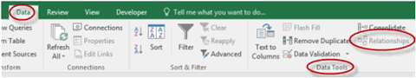
2. In the Manage Relationships dialog box, select New .  
   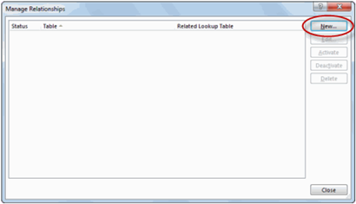
3. In the Create Relationship dialog box, enter the tables and columns you want to be related, and click OK .  
   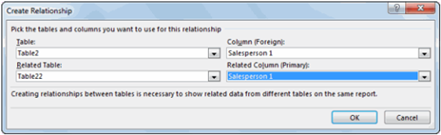
4. The information now appears in the Manage Relationships dialog box.  
   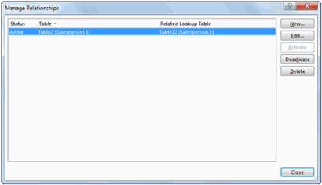

### Inserting Pivot Charts

Pivot charts are simply charts that use the data in your pivot table. Pivot charts make it easy to visualize your data.

To insert a pivot chart:

1. Select any cell in the pivot table.
2. On the PivotTable Tools Analyze tab ( PivotTable Tools Options tab in Excel 2007/2010), in the Tools group, click the PivotChart command:  
   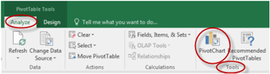
3. In the Insert Chart dialog box, select the type of chart to insert and click OK :  
   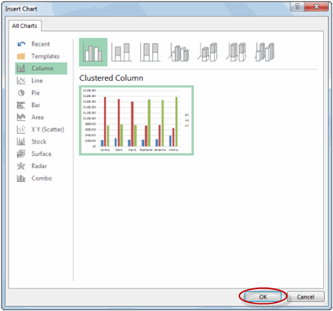

Watch and follow along as your instructor demonstrates some of the functionality of pivot charts using the PivotTable Demo.xlsx file in your Excel2016.3/Demos folder. Note that as changes are made to pivot charts, the pivot table on which the chart is based is automatically updated.

More Pivot Table Functionality

Pivot tables are one of the most powerful and useful tools in Excel. Watch and follow along as your instructor demonstrates additional pivot table functionality, including:

1. How to Sort , Filter , Move , Remove , and format fields by right-clicking on them:
2. How to change or update the data source.
3. How to Refresh the pivot table.
4. How to filter the data in the pivot table using the filter drop-down arrows:
5. Some of things you can do from the PivotTable Tools Analyze tab:
6. Some of things you can do from the PivotTable Tools Design tab:

Exercise 1 Working with Pivot Tables

15 to 25 minutes

In this exercise, you will practice using pivot tables, pivot charts, and Slicers.

1.

Open PivotTables.xlsx from your Excel2016.3/Exercises folder.

2.

Insert a pivot table in a new worksheet showing total sales by company. Format the numbers as Currency and show zero decimal places. The pivot table should look like the following image:

3.

Insert a pivot chart that looks like the chart below:

4.

Insert a pivot table in a new worksheet showing total sales in each calendar year by industry. Format the numbers as Currency and show zero decimal places. The pivot table should look like the following image:

5.

Insert Slicers to analyze sales by salesperson and product in addition to industry.

Exercise Solution

1.

To insert a pivot table showing total sales by company and to format the numbers as Currency and show zero decimal places:

A.

Select any cell in the table (cells A1:H62).

B.

On the Insert tab, in the Tables group, click the PivotTable command (and then select PivotTable in Excel 2007/2010):

C.

In the Create PivotTable dialog box, verify that Excel has selected the correct range, select where you want the pivot table to show up (select New Worksheet ), and then click OK :

D.

In the PivotTable Field List , drag and drop Company into the Row Labels box and Sale Amount into the Values box:

E.

Click Sum of Sale Amount and select Value Field Settings :

F.

Click Number Format :

G.

In the Format Cells dialog box, select Currency , change the number of decimal places to "0", and click OK :

H.

In the Value Field Settings dialog box, click OK :

2.

To insert the pivot chart showing total sales by company:

A.

Select any cell in the pivot table.

B.

On the PivotTable Tools Analyze tab ( PivotTable Tools Options tab in Excel

2007/2010), in the Tools group, click the PivotChart command:

C.

In the Insert Chart dialog box, select Pie charts, select the first pie chart, and then click OK :

3.

To insert a pivot table showing total sales in each calendar year by industry and to format the numbers as Currency and show zero decimal places:

A.

Select the sheet named Data and then select any cell in the table (cells A1:H62).

B.

On the Insert tab, in the Tables group, click the PivotTable command (and then select PivotTable in Excel 2007/2010):

C.

In the Create PivotTable dialog box, verify that Excel has selected the correct range, select where you want the pivot table to show up (select New Worksheet ), and click OK :

D.

In the PivotTable Field List , drag and drop Industry into the ROW box ( Row Labels box in Excel 2007/2010), Calendar Year into the COLUMN box ( Column Labels box in Excel 2007/2010), and Sale Amount into the VALUES box:

E.

Click Sum of Sale Amount and select Value Field Settings :

F.

Click Number Format :

G.

In the Format Cells dialog box, select Currency , change the number of decimal places to "0", and click OK :

H.

In the Value Field Settings dialog box, click OK :

4.

To insert Slicers to analyze sales by salesperson and product in addition to industry:

A.

Select any cell in the pivot table.

B.

On the PivotTable Tools Analyze tab ( PivotTable Tools Options tab in Excel

2007/2010), in the Filter group ( Sort & Filter group in Excel 2007/2010), click the Insert Slicer command (and select Insert Slicer in Excel 2007/2010):

C.

In the Insert Slicers dialog box, check the Product and Salesperson check boxes and click OK :

D.

To use the Slicer, simply select one of the fields in either Slicer to filter your data by that field.

Conclusion

In this lesson, you learned to use pivot tables to analyze data, to edit pivot tables, to format pivot tables, to insert pivot charts, and to use Slicers.